Habitare annual complaints and service improvement report and compliance with the Complaint Handling Code
Introduction
This report summarises the complaints received during 2024 including the subject areas and changes made to our services. It is a requirement of the Regulator of Social Housing’s Transparency, Influence and Accountability Standard to publish information on the number, nature and outcome of complaints.
Habitare Homes is a member of the Housing Ombudsman Service and adheres to the Housing Ombudsman guidance. We publish our compliance with the Housing Ombudsman’s Code annually and operate a two stage complaint process.
During 2024 our homes were managed by three managing agents (Grand Union, Longhurst and Raven). The managing agents are all registered providers of social housing and their contact details are provided on our website. Note – Longhurst and Grand Union merged to create Amplius on 16 December 2024.
Stage one complaints are handled by our managing agents. Any complaints which are escalated to stage two are reviewed with Habitare Homes before the complaint outcome is determined. The complaints process is also published on our website.
Annual Review 2024
During 2024, we experienced an increase in complaints, with volumes rising from 15 complaints in 2023 (7 at Stage 1 and 8 at Stage 2) to 44 complaints this year (31 at Stage 1 and 13 at Stage 2). This increase is largely driven by defects in newly delivered homes.
Our housing stock grew by 23% year-on-year, from 210 homes in 2023 to 259 homes in 2024. When adjusted for stock size, our TSM performance for complaints per 1000 homes rose from 7.1% of homes in 2023 to 17% in 2024, reflecting an increase in reported issues as the number of completed homes increased.
We have implemented several, particularly in defect management and complaint handling processes, which are expected to positively impact performance and customer satisfaction in the future.
Communication
Complaints are acknowledged within five days of receipt and logged by the managing agent responsible. Stage one complaints will be investigated, and a full response sent within 10 working days. If this does not resolve the complaint the complainant can request a stage two review where an independent review will take place involving the Habitare team. A written response will then be issued within 20 working days unless otherwise agreed with the complainant. Following this, the complaint can be referred to the Housing Ombudsman.
Three cases were escalated to the Housing Ombudsman in the year. These cases remain with the Housing Ombudsman awaiting review and determination. Two of these cases relate to defect management and the other relates to estate management. The complaints were escalated to the Housing Ombudsman following completion of our complaints process and are expected to be determined in 2025.

Complaint summary
Total complaints in 2024: 44
- Stage 1 complaints: 31
- Stage 2 complaints: 13
- Escalation rate from Stage 1 to Stage 2: 42%
(13 out of 31 Stage 1 complaints were escalated by customers to seek an acceptable resolution)

Complaints by tenure  Stage 1:  - Shared Ownership: 27  - Rent: 4  Stage 2:  - Shared Ownership: 10  - Rent: 3 | 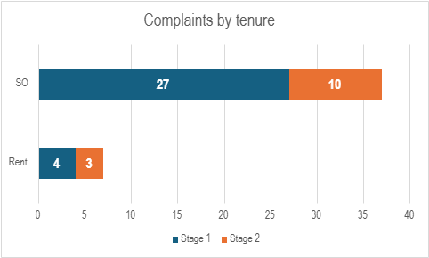
Cause of complaint  - 86% (38 complaints) related to defects in new-build properties.  - 7% (3 complaints) related to repairs.  - 2% (1 complaint) related to estate charges.  - 5% (2 complaints) related to other issues (e.g., pest control). | 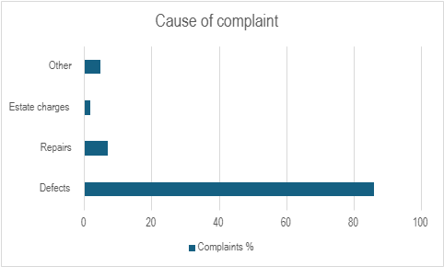
Complaints by location  Tattenhoe 1  Grantham 2  Alconbury 3  Campbell Wharf 4  Towergate 8  Lewes 26 | 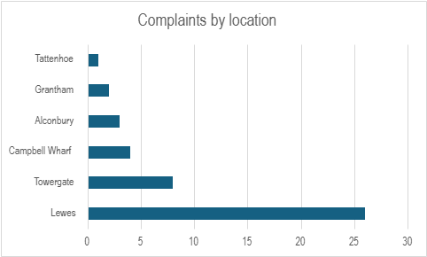
Fairness in complaint handling
We have not refused the escalation of any complaints this year.
Service Improvement
Where something has gone wrong, we take appropriate steps to put things right. To address the high escalation rate and recurring themes in complaints, several service improvements have been implemented during 2024:
- Strengthening Defect Management:
  - Contract terms for new developments have been enhanced to improve defect response times.
  - Retention monies will be used more effectively where the original contractor is unable to deliver on defect resolutions.
  - Tracking of defects has been improved, with monthly reviews conducted of every site to monitor progress.
- Focus on Stage 1 Resolutions:
  - When a complaint is received it is important that the issue is resolved effectively at stage 1, negating the need for further escalation to resolve the issues.
  - We have developed an AI tool to assist in the review of complaints with our managing agents and ensure that all the issues are addressed. The tool assesses the customers complaints against our policy and the Housing Ombudsman code to ensure that all matters raised by the customer have been addressed in the response.
  - Regular review meetings have been introduced with our managing agents to identify and address patterns in complaints. This also forms a key part of the contract management plans introduced in 2024 with our managing agents.
- Improving Communication:
  - Alongside the use of AI, additional resources have been allocated to the complaints team to ensure timely responses.
  - Managing agents are now required to provide regular updates to residents and document their communication more thoroughly. Progress on resolution of complaints is tracked within our contract management process.
Learning from complaints
The dominant category of complaints continues to be new-build defects, which accounted for 86% of total complaints. These issues were particularly pronounced at the Lewes scheme, which alone accounted for 60% of all complaints.
Complaints from our other developments were fewer but similarly focused on defects and repairs. This reinforces the importance of managing resident expectations in new developments and ensuring that issues are resolved promptly.
The higher complaint volume from shared owners also reflects the frustrations experienced from new build defects. 93% of shared ownership stage one complaints were defect related, and 100% of stage 2.
A key factor driving complaints—especially those that escalated to Stage 2—was the perceived lack of timely communication and clarity from managing agents and contractors. Residents frequently cited delays and insufficient information as major sources of dissatisfaction. This was particularly evident in defect-related complaints, where the complexity of coordinating contractors and developers often led to extended timelines and poor communication. We are monitoring this monthly with each of the managing agents to ensure that residents are updated frequently on the status of their complaint, and this is a key priority for 2025.
The high escalation rate from Stage 1 to Stage 2 has also identified some clear areas for improvement in complaint resolution. For many residents, the initial response to their concerns at Stage 1 was insufficient to meet their expectations, requiring further investigation or follow-up at Stage 2. Analysis of Stage 2 complaints revealed that in 50% of cases, the resolution proposed at Stage 1 was either not implemented fully or not communicated effectively. We have developed an AI tool to assist in the identification of the issues that have caused the complaint and work with our managers to improve communication and accountability within the complaint-handling process. Progress on resolution of complaints is tracked within our contract management process.
We have already seen benefits from the implementation of our AI tool to support our managing agents in the resolution of complaints. This tool allows us to review the causes of the complaint and ensure that we fully identify and address each issue within our first response and resolution. We anticipate that the learning from Lewes alongside the use of our AI tool and process improvements will result in fewer complaints during 2025.
We take complaints very seriously and complaints management is a key service priority for Habitare Homes. We are sorry that these residents have experienced issues with the homes and services and provided and will continue to work with our partners to address the issues raised. Through our revised complaints process and support of AI in addressing issues we hope to see an improvement in the amount of complaints resolved at stage 1 of the process and an improvement in our complaints satisfaction measure through 2025.

